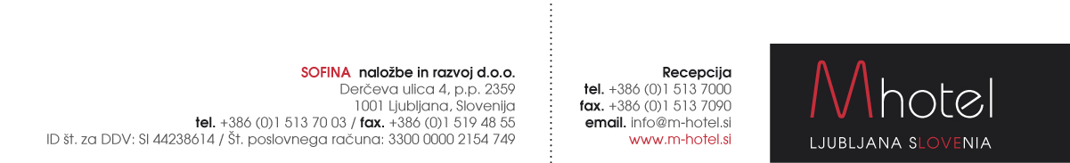

M HOTEL RESERVATION FORM www.m-hotel.si

FOR EERVC May 4-7 2022
Reservations to be sent to the following e-mail address: anja.novak@m-hotel.si

First and last names:
Room type and number of persons:
Arrival date:
Departure date:

Special rates:
Single room:  Double or twin room  Tourist tax supplement: | 110 EUR / night.  130 EUR / night (65 EUR / person)  3,13 EUR / person / night

Limited no. of the rooms are available. Reservations are »on request«

Credit card details
Card name |  |  |  |  |  |  |  |  |  |  |  |  |  |  |  |  |  |  |  |  | Card holder
Card number |  |  |  |  |  |  |  |  |  |  |  |  |  |  |  |  |  |  |  |  | Expiry date
CVC (3 or 4 - digit) |  |  |  |  |  |  |  |  |  |  |  |  |  |  |  |  |  |  |  |  | Signature
Date:
A credit card number and the expiry date are necessary to make and guarantee your booking. Please, return this form by fax or e-mail directly to the hotel: anja.novak@m-hotel.si

M hotel offers you a transfer service from/to the Ljubljana's airport. Rate: 30 EUR per vehicle upto 4 persons.
Our taxi driver will be waitting for you at the arrival gate with an M hotel sign and your name on it. Payment: directly to the transferist.
IN CASE YOU NEED OUR TRANSFER SERVICE PLEASE FILL IN YOUR FLIGHT DETAILS:
ARRIVAL DATE:
ARRIVAL TIME:
FLIGHT NUMBER:
NUMBER OF PERSONS:

